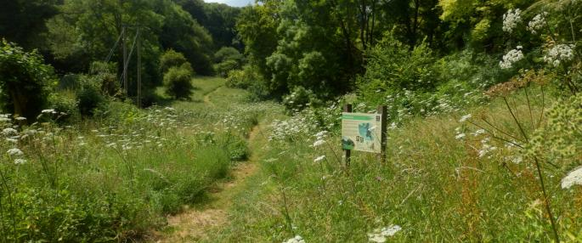


Bucks Badger Group
Badger Walk

Badger Walk

Bucks Badger Group are holding a badger Walk at Dancersend Nature Reserve
Sunday July 12th at 10.00 am

Dancersend is a nature reserve run by BBOWT near Wendover and has a wide variety of flora and fauna including, of course, badgers.

If you are interested in coming along, please phone:
Anne on 01494 715438 or 07079247797
Or Mike on 07787 955861
or email: anne_bourne@hotmail.com

For those who are not members of BBG or BBOWT a small donation
would be welcome

